Teacher: Ms. LeBrane
Course: 10th Grade Lit
Contact Information:LebraTa@richmond.k12.ga.us Google# 706-622-8891
Student Directions: Inside your packet you will find a copy of the short story “The Monkey Paw” by W.W Jacobs or page 9 in the Close Reading Notebook. Read the short story if you have not read the entire story and complete the assigned worksheets. When reading, make sure to keep notes of themes, plot, and conflicts in the short story. Refer to vocabulary words in your notes for more in depth understanding of words used in the short story. If you would like to access Canvas, to complete assignments, you will need your Close Reading Notebook, or you can open attachment. If there are any questions, I will be available by phone and email from 7am to 3pm. Have fun and enjoy the story!
Agenda
Day | Assignment
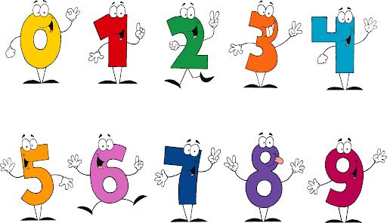  Tuesday  September 7, 2021 | If you have access to Canvas, please complete:  After reading the short story “The Monkey’s Paw” which starts on page 9 in your Close Reading Notebook, complete pages 5 -7 located in the All In One Student Companion Workbook.  If you do not have access to Canvas, please complete:  After reading the short story “The Monkey’s Paw” located in your Learn From Home Packet, also located in the Close Reading Notebook on page 9, complete workbook pages 5 -6 located in your packet or in the All In One Student Companion Workbook.
Wednesday  September 8, 2021 | If you have access to Canvas, please complete:  Complete the worksheets pages 8-10 in the All In One Student Companion Workbook.  If you do not have access to Canvas, please complete:  Complete the worksheets pages 8-10 in the packet or the All In One Student Companion Workbook.

